**Printable Resources Page for Parents**

**Websites** for Parent Information:

* Fight the New Drug <https://fightthenewdrug.org/>
* Dr Gail Dines <https://www.gaildines.com/>
* eSafety Commissioner <https://www.esafety.gov.au/>

Excellent NZ **Documentary** [*Our Kids Online: Porn, Predators and How to Keep Kids Safe*](https://vimeo.com/ondemand/ourkidsonline)

Online **Programs** to equip parents for tricky conversations with children and teenagers

* Culture Reframed Parents Program: <https://culturereframed.org/>
* Porn Resilient Kids <https://www.pornresilientkids.com/>

**Booklet** to equip parents to talk to their children:

How to Talk to Your Kids About Pornography

$15 at Catholic Bookshop, Manuka

Buy online at <https://www.catholicbookshop.org.au/>

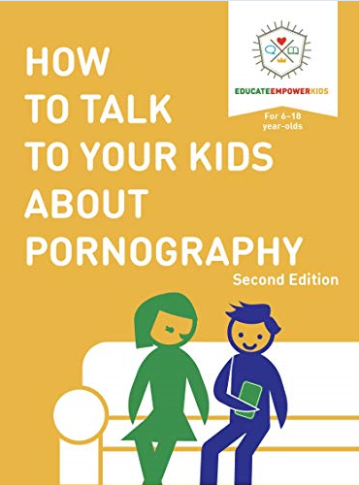

**Story books** to read *with* your younger children

* Milly’s Message: <https://protectingkidsonline.info> (ages 5-10 - Australian)
* Hamish and the Shadow Secret: <https://shadowsecret.info>  (ages 8-12 - Australian)
* Good Pictures Bad Pictures Junior (ages 3 to 6 - American)
* Good Pictures Bad Pictures (primary school children - American)

**Advocacy**

* If you’d like to get involved in raising awareness and helping find legislative, policy, educational and therapeutic solutions as a community check out <https://www.echildhood.org/>