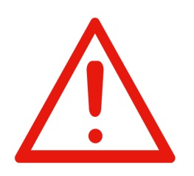**Form 3 - Parish/Agency Hazard List and Risk Assessment**

Parish/Agency: __________________________________________________________________________

Date of Risk Assessment / / . Risk Assessment Completed by _____________________

Items answered **No** on the **Health and Safety Hazard Checklist** (Form 2) should be transferred to this document, with a brief Hazard Description. Then, using the **Risk Assessment Table** on the next page, determine what the Consequences and Likelihood are from the risk and allocate it a Risk Level from the table. This information will then be used in **Control the Risks in your parish/agency**.

|  |  |  |  |  |
| --- | --- | --- | --- | --- |
| **Id #** | **Hazard Description** | **Consequences** | **Likelihood** | **Risk Level** |
| 1 |  |  |  |  |
| 2 |  |  |  |  |
| 3 |  |  |  |  |
| 4 |  |  |  |  |
| 5 |  |  |  |  |
| 6 |  |  |  |  |
| 7 |  |  |  |  |
| 8 |  |  |  |  |
| 9 |  |  |  |  |
| 10 |  |  |  |  |

**Five key points about assessing risk**

1. The WHS Act requires all risks to be dealt with, whether the risk is serious or mild and whether controlling it is difficult or easy.
2. Assessment must include risks to non-workers (contractors and the public) who may be affected by your activities.
3. Where groups of workers are especially at risk (young workers, inexperienced staff or disabled workers), they must be considered as part of the assessment.
4. Review the original assessment before introducing new work practices, equipment, machinery or chemicals.
5. Never rely solely on common sense in determining safe behaviour, as it is much less common than is generally assumed.